**UNIVERSAL-GANS**

A PROJECT REPORT

Submitted by

**VANI SETH (201B299)**

**TANISH KHANDELWAL (201B283)**

**GARIMA SHUKLA (201B109)**

Under the guidance of **Dr. P. S. BANERJEE**

Submitted in partial fulfilment of the degree

Of

**Bachelor Of Technology**

In

**COMPUTER SCIENCE AND ENGINEERING**

at



**JAYPEE UNIVERSITY OF ENGINEERING AND TECHNOLOGY GUNA,**

**MADHYA PRADESH (INDIA) – 473226**

**NOVEMBER-2022**

**DECLARATION**

We hereby declare that the project entitled “**Universal GANs**” was submitted for the B.Tech. (CSE) the degree is our original work and the project has not formed the basis for the award of any other degree, diploma, fellowship, or any other similar titles.

VANI SETH (201B299)

TANISH KHANDELWAL (201B283)

GARIMA SHUKLA (201B109)

**Signature of the Students**

**Place: JUET GUNA**

**Date:**

**CERTIFICATE**

I certify the project entitled, “**Universal-GANs**” submitted by **VANI SETH (201B299), TANISH KHANDELWAL (201B283), and GARIMA SHUKLA (201B109)** in partial fulfilment of the Degree of Bachelor of Technology in Computer Science and Engineering at the Department of Computer Science and Engineering, Jaypee University of Engineering and Technology is a work under my supervision. To per best of my knowledge and belief, there is no infringement of copyright and intellectual property rights. Also, this work has not been submitted partially or wholly to any other Institute or University for the award of any other degree or diploma. In case of any violation concern, students will solely be responsible.

**SUPERVISOR**

Dr. P. S. BANERJEE

**ACKNOWLEDGEMENT**

Any endeavour cannot lead to success unless and until a proper platform is provided for the same. This is the reason why; we find ourselves very fortunate to complete our work on a minor project under supervision of **Dr. P. S. Banerjee.** Our sincere gratitude to him, for having faith in us and thus allowing us to carry out a project on technology completely new to us, for which we had to research and learn many new things, which will help us deal with advanced work in future. He helped immensely by guiding us throughout the project in any of the possible ways he could. Last but not the least, we would like to thank the Dept. Of Computer Science and Engineering who created this opportunity.

VANI SETH (201B299)

TANISH KHANDELWAL (201B283)

GARIMA SHUKLA (201B109)

**ABSTRACT**

Humanity has always been inspired by space travel, and owing to contemporary telescopes, it is now feasible to study celestial bodies thousands of light-years away. It is now possible to create new representations of space by using the increasing quantity of real and imagined images of space that are available on the web with current Deep Learning architectures like Generative Adversarial Networks. With the help of Lightweight GAN, a collection of photos we downloaded from the web, and the Galaxy Zoo Dataset, we created thousands of new images of galaxies and heavenly bodies for this project. Finally, by fusing these images together, we were able to create a comprehensive representation of the cosmos.

**Keywords:** Astronomy, Deep Learning, Generative Adversarial Networks.

**Table of Figures**

|  |  |  |
| --- | --- | --- |
| **Figure** | **Title** | **Page No.** |
| Fig 1 | Block Diagram of General Framework | 9 |
| Fig 2 | System Architecture | 12 |
| Fig 3 | GAN Architecture | 13 |
| Fig 4 | Neural Network Architecture | 16 |
| Fig 5 | Neural Network Block Diagram | 17 |
| Fig 6 | Structure of a Neuron | 19 |
| Fig 7 | GAN Basic Architecture | 21 |
| Fig 8 | Generator Architecture | 22 |
| Fig 9 | Discriminator Architecture | 23 |
| Fig 10 | Universe Image | 24 |
| Fig 11 | Landing Page of Website |  |

**Table of Contents**

Title page i

Declaration of the Student ii

Certificate of the guide iii

Abstract iv

Acknowledgement v

List of Figure vi

**Chapter - 1 INTRODUCTION**

1.1 Problem Definition

1.2 Project Overview

**Chapter - 2 LITERATURE SURVEY**

2.1 Related Works

2.1.1 General Adversarial Networks

2.1.2 Applications of GANs in Astronomy

2.2 Feasibility Study

**Chapter - 3 SYSTEM ANALYSIS & DESIGN**

3.1 System Requirement

3.1.1 Hardware Requirements

3.1.2 Software Requirements

3.2 System Design

3.2.1 System Architecture

3.2.1 GANs Architecture

3.3 Methodology

3.4 Feasibility Structure

**Chapter - 4 FEATURE EXTRACTION**

4.1 Neural Networks

4.2 General Adversarial Networks

4.2.1 Generator

4.2.2 Discriminator

**Chapter - 5 RESULTS AND DISCUSSION**

**Chapter - 6 CONCLUSION AND FUTURE WORK**

6.1 Conclusion

6.2 Future Work

**Chapter - 7 REFERENCES**

**Chapter - 8 AUTHORS**

**CHAPTER 1**

**INTRODUCTION**

* 1. **Problem Definition**

Data scarcity is huge problem when it comes to training machine learning or deep learning models. Data Scarcity is when there is limited amount or a complete lack of labelled training data, it can also occur when is data imbalance i.e., when there is lack of data for a given label compared to the other labels. People have wondered whether it is possible to use GANs for generating training data to be used in low-data regimes. Although there has not been much success there, it is still conceivable to combine two data sources to produce more realistic and practical training data. If we have a large amount of unlabelled data and we feed it to a refiner (powered by GANs) that is trained to produce more realistic training data given some basic labelled synthetic data, it can reduce the cost of generating supervised datasets and can help in a variety of machine learning and deep learning tasks, particularly in the areas like astronomy where data is scarce and costly.

* 1. **Project Overview**

The project “Universal- GANs” mainly focuses on:

1. Scrapping images from web.
2. Creating a dataset of the relevant images
3. Training a Deep Learning model (GANs) to generate new images.
4. Using the generated images to create a comprehensive representation of the cosmos.

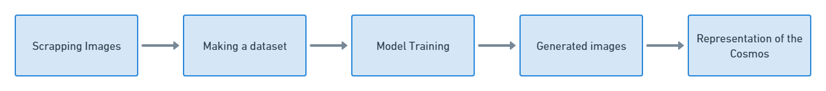

Figure 1. Block Diagram of General Framework

Figure 1 represents a block diagram that showcases the flow of how the project proceeds.

**CHAPTER-2**

**LITERARTURE SURVEY**

**2.1 RELATED WORKS**

**2.1.1 General Adversarial Networks**

General Adversarial Networks were first introduced by [1], and they were immediately very successful, regarded as one of the major breakthroughs in AI history. GANs are made up of two separate networks. The generator, network that creates fresh images in a convincing enough manner to trick the counterpart and a discriminator, which detects whether an image is fake.

With this technique, it was possible to generate new work of art [2], improve resolution of existing photos [3] and even create highly credible deepfake images and videos [4]. StyleGAN2 currently represents the state-of-the-art of these networks, with its adaptive discriminator augmentation (ADA). The Lightweight GAN [5], a further simplified version of this model capable of obtaining good results but with a lighter and shorter training phase, was used as an additional alternative for working in circumstances with minimal data. The design combines a self-supervised discriminator that has been trained as a feature-encoder with a skip-layer channel-wise excitation module to achieve this.

**2.1.2 Application of GANs in Astronomy.**

The so-called GalaxyGAN has been utilised in astronomy earlier to recover characteristics from astronomical photographs of galaxies. Deconvolution techniques are commonly employed to enhance the quality of these data, although they are quite limited. Astrophysical images are frequently disrupted by noise. With the use of GANs, missing features can be recovered, resulting in more accurate and dependable outcomes. ExoGAN, a model that can perform this task with a lower computing cost than previous ones and can distinguish molecular characteristics, atmospheric trace-gas abundances, and planetary parameters, was created using GANs in this field for atmospheric retrievals on exoplanets.

**CHAPTER-3**

**SYSTEM ANALYSIS AND DESIGN**

**3.1 SYSTEM REQUIREMENT**

The process of deciding on the requirements of a software system, which determines the responsibilities of a system, is called requirement analysis. Requirement analysis is a software engineering task that bridges the gap between system level requirements engineering and software design. Requirement reengineering activities result in the specification of software’s operational characteristics indicate the software’s interface with other system elements and establish constraints that the software must meet.

The following section presents the detailed requirement analysis of our project.

**3.1.1 HARDWARE REQUIREMENTS:**

CPU (3.0 GHz or faster) or faster 64-bit Dual Core processor like Intel core-2 duo.

Memory: 4GB (DDR4 | DDR2) RAM or more

GPU: 2GB dedicated GPU or Intel IrisXe integrated

**3.1.2 SOFTWARE REQUIREMENT:**

Windows 8, 10 or Windows 11

Python 3.10.5

Google Colab

Visual Studio Code (IDE)

**3.2 SYSTEM DESIGN**

**3.2.1 System Architecture**

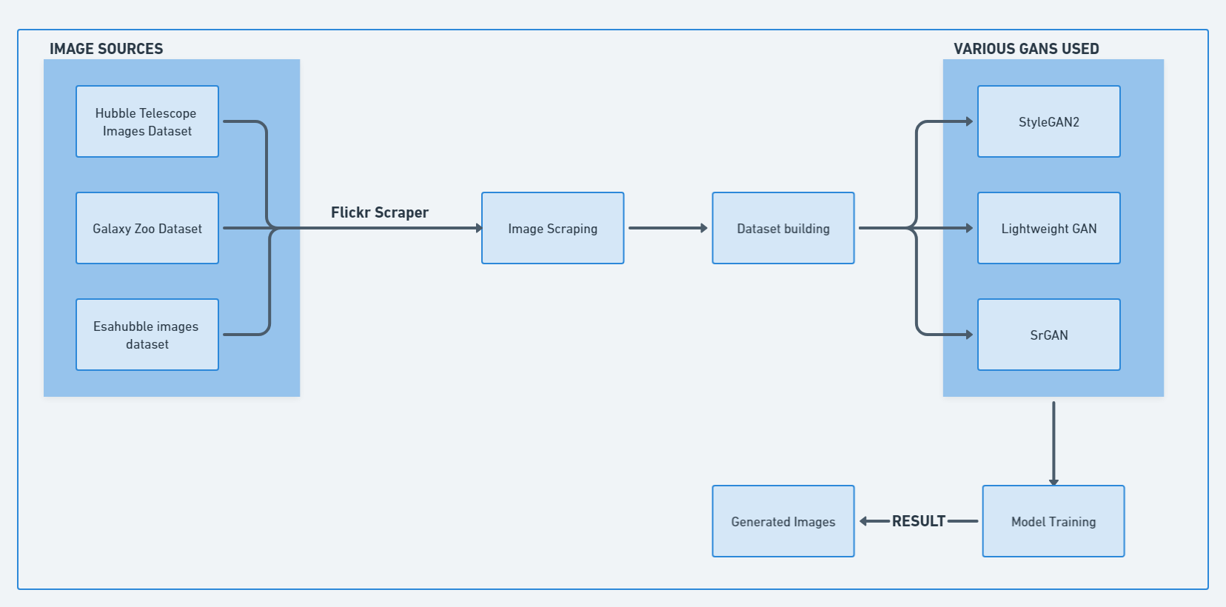

Figure 2. System Architecture

Figure 2 describes the system architecture of the whole project. It represents how we have scrapped images from different sources to build a dataset. After the dataset building, we have applied different types of GANs to produce the desired output that is different images of celestial bodies and galaxies and then finally combining them to create a single image of the universe.

**3.2.1 GANs Architecture**

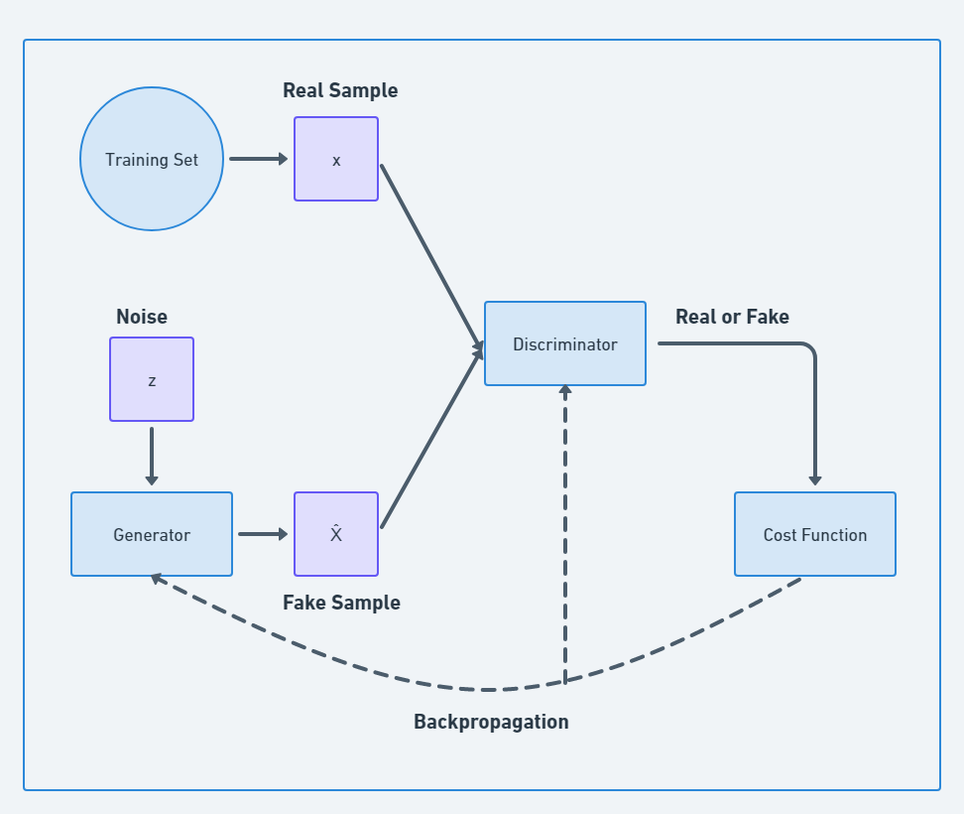

Figure 3. GAN Architecture

Figure 3 describes the working of GANs. GANs take a real sample and compares it with a fake sample that is generated by the generator. The comparison is done by the discriminator, the discriminator updates the cost function according to accuracy of the generated image to the real one. This process keeps happening until the discriminator can no longer differentiate between the real sample and the fake sample.

**3.3 METHODOLOGY**

To train the network to generate celestial bodies, it is necessary to create a suﬃciently large and heterogeneous dataset. To do this, we collected both real space images and artistic representations of the universe using the Flickr Scraper library, together with some handwork for manually downloading images from the web. The collected dataset was then manually revised to discard inconsistent images (e.g., the trivial ones or those having too low resolution). As the images collected online were all diﬀerent sizes, they were then cropped in a centred squared way, ensuring that the image was not deformed during the resize phase. In the end of this process, we obtained a dataset of 283 coherent, good quality, and squared images. We also exploited the Galaxy Zoo Dataset [5], a large collection with hundreds of thousands of space images collected by telescopes, to carry out further tests and obtain real galaxy images to be merged into a single wide view. The Generative Adversarial Network chosen to carry out the experiments is a Lightweight GAN [6], a version very similar to the state-of-the-art StyleGAN2 but lighter and easier to train. In fact, it has been demonstrated that this network is able to converge in a few hours, on a single GPU, with a few hundred training samples and achieving remarkable quality results. For these reasons, it is the more suitable architecture in our context.

**3.4 FEASIBILITY STRUCTURE**

* **Financial Stability**: Although the technology may be expensive, it only requires a single investment because images may be produced with ease once a model has been taught. Additionally, doing such a work on the cloud can significantly lower costs and be more effective due to the increased availability of cloud resources.
* **Technical feasibility**: The technologies utilised are open source, which allows anybody to contribute to them, and all of the hardware and software used are readily available on the market. The information gathered from the user will be kept on their local system and utilized to enhance the application's functionality and accuracy.
* **Economic Feasibility**: Economic feasibility defines whether the expected

benefit equals or exceeds the expected costs. It is also commonly referred to as

cost/benefit analysis. The procedure is to determine the benefits and the

savings expected from the system and compare them with the costs. A

proposed system is expected to outweigh the costs.

* **Operational Feasibility**: Operational feasibility is the measure of how well a

proposed system solves the problems with the users. Operational feasibility is

dependent on human resources available for the project and involves projecting

whether the system will be used if it is developed and implemented. The

project is operationally feasible for the users as nowadays almost all the

teachers/staffs are familiar with digital technology.

**CHAPTER - 4**

**FEATURE EXTRACTION**

**4.1 NEURAL NETWORKS**

Neural networks are composed of simple elements operation in parallel. These elements are inspired by biological nervous systems. As in nature, the network function is determined largely by the connections between elements. We can train a neural network to perform a particular function by adjusting the values of the connections (weights) between elements.

Commonly neural networks are adjusted, or trained, so that a particular input leads to a specific target output. There, the network is adjusted, based on a comparison of the output and the target, until the network output matches the target. Typically, many such input/target pairs are used in this supervised learning to train a network.

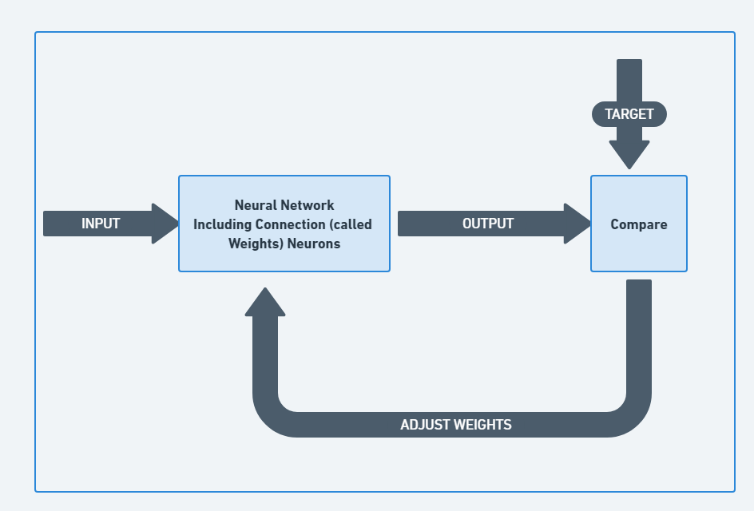

Figure 4. Neural Networks Architecture

Figure 4 represents the working of neural networks.

Neural networks have been trained to perform complex functions in various fields of application including pattern recognition, identification, classification, speech, and vision and control systems. Today neural networks can be trained to solve problems that are difficult for conventional computers or human beings.

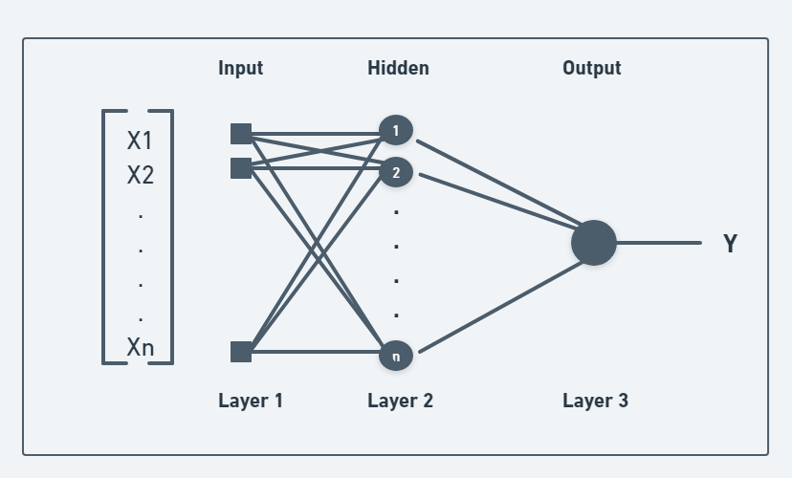

Figure 5. Neural Networks Block Diagram

Figure 5 demonstrates different layers that are consisted in a neural network.

The Neural network [9] is typically organized in layers. Layers are being made up of many interconnected ‘nodes’ which contain an ‘activation function’. A neural network may contain the following 3 layers:

1. **Input Layer**

The purpose of the input layer is to receive as input the values of the explanatory attributes for each observation. Usually, the number of input nodes in an input layer is equal to the number of explanatory variables. ‘Input layer’ presents the patterns to the network, which communicates to one or more ‘hidden layers.’

The nodes of the input layer are passive, meaning they do not change the data. They receive a single value on their input and duplicate the value to their many outputs. From the input layer, it duplicates each value and sent to all the hidden nodes.

1. **Hidden Layer**

The purpose of the input layer is to receive as input the values of the explanatory attributes for each observation. Usually, the number of input nodes in an input layer is equal to the number of explanatory variables. ‘Input layer’ presents the patterns to the network, which communicates to one or more ‘hidden layers.’

The nodes of the input layer are passive, meaning they do not change the data. They receive a single value on their input and duplicate the value to their many outputs. From the input layer, it duplicates each value and sent to all the hidden nodes**.**

1. **Output Layer**

The hidden layers then link to an ‘output layer.’ Output layer receives connections from hidden layers or from the input layer. It returns an output value that corresponds to the prediction of the response variable. In classification problems, there is usually only one output node. The active nodes of the output layer combine and change the data to produce the output values.

The ability of the neural network to provide useful data manipulation lies in the proper selection of the weights. This is different from conventional information processing.

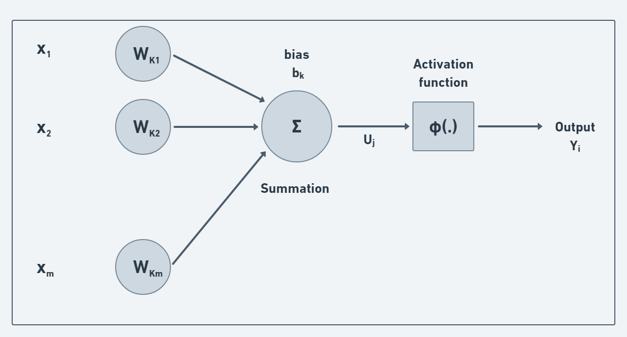

Figure 6. Structure of a Neuron

Figure 6 represents how a neuron takes an input, applies the activation function to produce the output.

The neuron gets some input signals or values (represented to dendrites) and it has output signal (represented to axon). In terms of machine learning or deep learning, input values or the input signal is passed through synapses to your neuron which is a hidden layer, and then your neuron has an output value. Each input value is the independent variable and the output value can be several types like continuous, binary, or categorical [10].

Weights are crucial on how Neural Network learn. By adjusting the weights, the neural network decides what signal is important and what signal is not important to neuron. After we have input and weight. The first step is added up, multiply by the weight and the weighted sum of all the input values.

**4.2 GENERATIVE ADVERSARIAL NETWORKS**

Generative Adversarial Networks (GANs) were first introduced in 2014 by Ian Goodfellow et. al. and since then this topic itself opened up a new area of research.

Generative Adversarial Networks, or GANs for short, are an approach to generative modelling using deep learning methods, such as convolutional neural networks [8].

Generative modelling is an unsupervised learning task in machine learning that involves automatically discovering and learning the regularities or patterns in input data in such a way that the model can be used to generate or output new examples that plausibly could have been drawn from the original dataset.

GANs are a clever way of training a generative model by framing the problem as a supervised learning problem with two sub-models: the generator model that we train to generate new examples, and the discriminator model that tries to classify examples as either real (from the domain) or fake (generated). The two models are trained together in a zero-sum game, adversarial, until the discriminator model is fooled about half the time, meaning the generator model is generating plausible examples [8].

GANs are an exciting and rapidly changing field, delivering on the promise of generative models in their ability to generate realistic examples across a range of problem domains, most notably in image-to-image translation tasks such as translating photos of summer to winter or day to night, and in generating photorealistic photos of objects, scenes, and people that even humans cannot tell are fake.

Some of the most popular GAN formulations are:

* Transforming an image from one domain to another (CycleGAN),
* Generating an image from a textual description (text-to-image),
* Generating very high-resolution images (ProgressiveGAN) and many more.

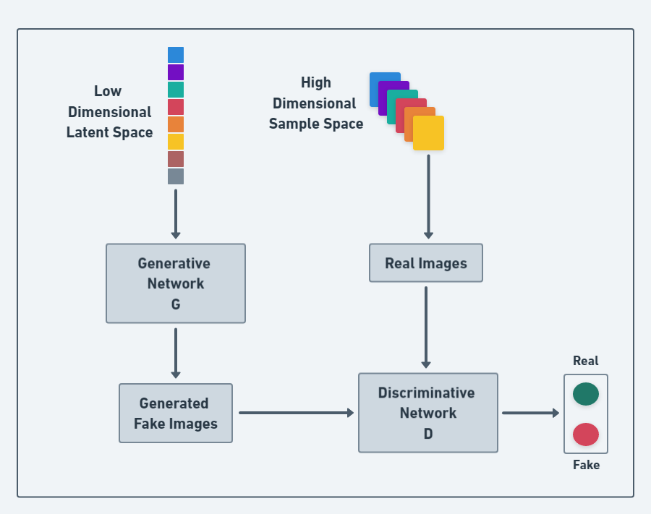

Figure 7. GAN Basic Architecture

Figure 7 represents the working generator and discriminator that are involved in GANs. It shows how a low-quality image is generated by the Generator and high-quality real images are given to discriminative network to differentiate between the real and generated image.

**4.2.1 GENERATOR**

The Generator generates synthetic samples given a random noise [sampled from a latent space] and the Discriminator is a binary classifier that discriminates between whether the

input sample is real [output a scalar value 1] or fake [output a scalar value 0] [7].

Samples generated by the Generator is termed as a fake sample. As you see in Fig 4.2.1 and Fig 4.2.2 that when a data point from the training dataset is given as input to the Discriminator, it calls it out as a Real sample whereas it calls out the other data point as fake when it’s generated by the Generator.

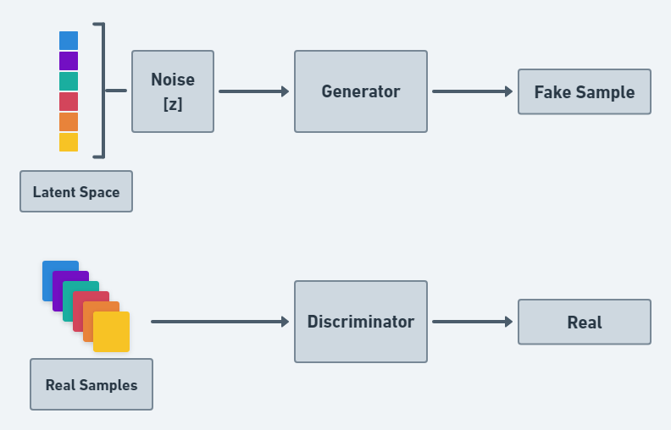

Figure 8. Generator Architecture

Figure 8 demonstrates the working of generator. The generator adds noise to some latent sample to generate a fake sample.

**4.2.2 DISCRIMINATOR**

The Discriminator wants to do its job in the best possible way. When a fake sample [which are generated by the Generator] is given to the Discriminator, it wants to call it out as fake but the Generator wants to generate samples in a way so that the Discriminator makes a mistake in calling it out as a real one. In some sense, the Generator is trying to fool the

Discriminator [7].

The discriminator in a GAN is simply a classifier. It tries to distinguish real data from the data created by the generator. It could use any network architecture appropriate to the type of data it's classifying.

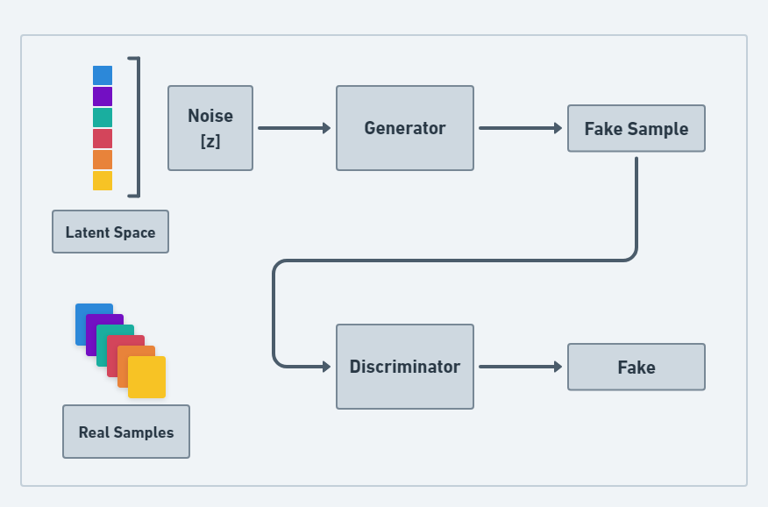

Figure 9. Discriminator Architecture

Figure 9 demonstrates the working of the discriminator and that it takes the fake sample and real sample differentiate between them.

**CHAPTER- 5**

**RESULTS AND DISCUSSION**

We were able to ultimately receive results for the trained GAN model after a training period of around 18 hours and 300 epochs. The outcomes were created images that were largely indistinguishable from actual images. After practising in the same setting, we produced photos on the Galaxy Zoo Dataset that were incredibly reliable. In this instance, the trained network was able to create outputs that were virtually recognisable from the original ones because to the number and simplicity of the input photos. Zoo dataset to produce a comprehensive perspective of the cosmos. We first downloaded 3000 galaxies from the network, and 10 more were chosen as blank space since they were so plain and nearly entirely black. It provides a rating based on the variety of images produced as well as their credibility while taking into account the distribution of classes from the training set. By computing the Structural Similarity Index Measure (SSIM), a widely used index of similarity between two photos, each image pair—real and fake—was compared.

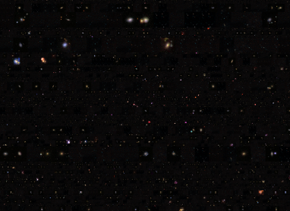

Figure 10. Universe Image created using generated Images

Figure 10 represents the generated image of the universe.

**CHAPTER- 6**

**CONCLUSION AND FUTURE WORK**

**6.1 CONCLUSION**

We created many reliable photographs of a variety of different celestial bodies and galaxies. Finally, we combined the images to create a stunning wide-view of a section of the cosmos. Multiple methods have been utilised to assess the results' quality, including (a) evaluating objective metrics and parameters extensively used in the Generative Adversarial Networks framework, and (b) utilising purely aesthetic evaluations and detecting approaches employing pre-trained networks. The resulting network demonstrates the utility and potency of generative adversarial networks by producing visuals valuable in the fields of art and graphics, as well as serving as a tool for data augmentation or the classification of planets or galaxies.

Additionally, we created a website using HTML/CSS/JS stack to showcase the results obtained.

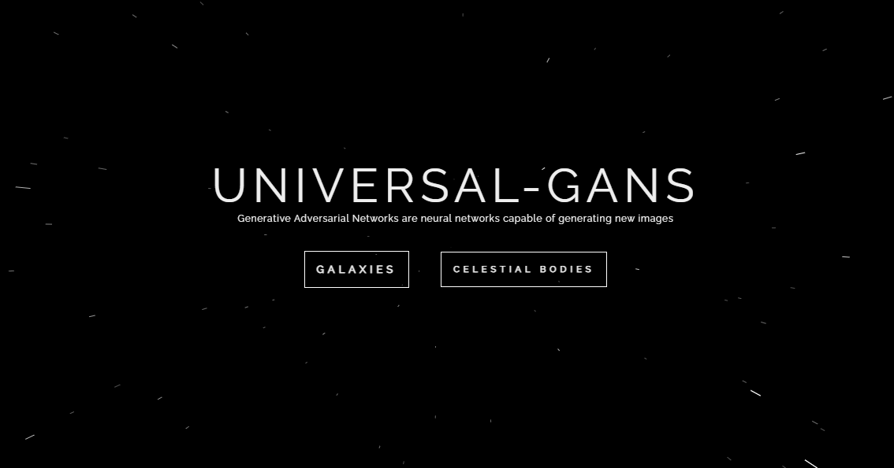

Figure 11. Landing Page of Website to showcase results obtained

In Figure 11, We have showcased the landing page of the website that shows the generated images by GANs network.

**6.2 FUTURE WORK**

Our project focuses on generating new images from existing images of the universe taken by various telescopes. GANs are a very powerful concept they can be applied in many other ways to enhance research work.

Along with generating new images, GANs can also be applied to recover features in astrophysical images of galaxies beyond the deconvolution limit [11]. Beyond the deconvolution limit, GANs can be used to recover features in astronomical photographs of galaxies in addition to creating new images. The optical system of the telescope, the detector used to collect the data, and other sources of random and systematic noise from the sky background all limit the detection of astrophysical objects. GANs can be used to make the image quality better and of higher definition and along with that remove the random noise from the background to have a clearer picture of the object.

Astronomical data, especially astronomical images can have unexpected outliers. As the data set size increases, automated methods for detecting these outliers are critical. Thus, Anomaly detection in astronomical images [12] is possible with the help of GANs. Unsupervised machine learning lends itself to this problem, as it allows for outlier identification without expert labelling or assumptions about expected outliers. We can also use Generative Adversarial Networks of these outlier identification. GANs can model complex distributions of high-dimensional data.

**CHAPTER - 7**

**REFERENCES**

[1] Goodfellow, I.J., Pouget-Abadie, J., Mirza, M., Xu, B., Warde-Farley, D., Ozair, S.,Courville, A., Bengio, Y.: Generative adversarial networks (2014)

[2] Elgammal, A., Liu, B., Elhoseiny, M., Mazzone, M.: Can: Creative adversarial networks, generating "art" by learning about styles and deviating from style norms (2017)

[3] Zhang, W., Liu, Y., Dong, C., Qiao, Y.: Ranksrgan: Super resolution generative adversarial networks with learning to rank (2021)

[4] Mirsky, Y., Lee, W.: The creation and detection of deepfakes. ACM Computing Surveys54(1), 1–41 (Apr 2021). <https://doi.org/10.1145/3425780>, <http://dx.doi.org/10.1145/3425780>

[5] Willett, K.W., et al., L.: Galaxy Zoo 2: detailed morphological classiﬁcations for 304 122 galaxies from the sloan digital sky survey. Monthly Notices of the Royal Astronomical Society 435 (4), 2835–2860 (Sep 2013). <https://doi.org/10.1093/mnras/stt1458>, <http://dx.doi.org/10.1093/mnras/stt1458>,

<http://dx.doi.org/10.1093/mnras/stt1458>

[6]<https://opensource.googleblog.com/2017/12/tfgan-lightweight-library-for-generative-adversarial-networks.html>

[7] <https://neptune.ai/blog/6-gan-architectures>

[8]<https://machinelearningmastery.com/what-are-generative-adversarial-networks-gans/>

[9]<https://medium.com/@rinu.gour123/artificial-neural-network-for-machine-learning-structure-layers-2a275f73f473>

[10] <https://medium.com/@PK_KwanG/the-neuron-ee579378283e>

[11] Kevin Schawinski, Ce Zhang, Hantian Zhang, Lucas Fowler and Gokula Krishnan Santhanam.: Generative adversarial networks recover features in astrophysical images of galaxies beyond the deconvolution limit. Monthly Notices of the Royal Astronomical Society: Letters, Volume 467, Issue 1, May 2017, Pages L110–L114, <https://doi.org/10.1093/mnrasl/slx008>

[12] Kate Storey-Fisher, Marc Huertas-Company, Nesar Ramachandra, Francois Lanusse, Alexie Leauthaud, Yifei Luo, Song Huang.: Anomaly Detection in Astronomical Images with Generative Adversarial Networks

<https://doi.org/10.48550/arXiv.2012.08082>

**CHAPTER – 8**

**AUTHORS**

1. **Vani Seth**

**Email:** [201b299@juetguna.in](mailto:201b299@juetguna.in)

**Contact: +91 7906966199**

1. **Tanish Khandelwal**

**Email:** [201b283@juetguna.in](mailto:201b283@juetguna.in)

**Contact: +91 7378427998**

1. **Garima Shukla**

**Email:** [201b109@juetguna.in](mailto:201b109@juetguna.in)

**Contact: +91 7510068710**